**Name: N. NITHIN**

**Roll no: 2420030488**

**Section: S2**

**WEEK 4**

**Construction of different VLANs and TRUNKING using cisco packet tracer**

Constructing different VLAN’s(Virtual local area networks) and configuring trunking using Cisco Packet Tracer involves a few steps:

Trunking is used in a network to allow multiple VLANs to communicate across network devices (like switches) over a single physical link. It enables the transportation of traffic from different VLANs over the same link, reducing the need for multiple physical connections and ensuring that VLAN segmentation is maintained across the network.

**Step 1: Setting up network topology**

**Network Architecture**

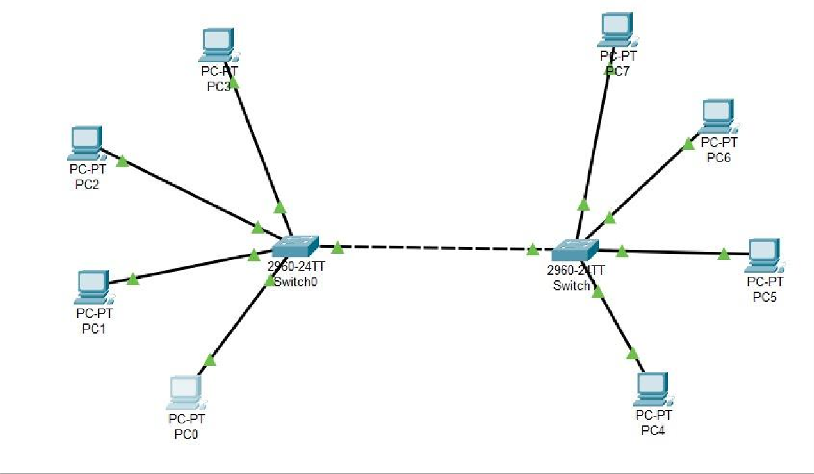

**Devices:**

* Switch 1(S1)
* Switch 2(S2)
* PCs (End Devices)

PC1 and PC2 connected to S1 (assigned to VLAN 10)

PC3 and PC4 connected to S1 (assigned to VLAN 20)

PC5 and PC6 connected to S2 (assigned to VLAN 10) PC7 and PC8 connected to S2(assigned to VLAN 20)

**VLANs:**

* VLAN 10: IP range 192.168.10.0/24
* VLAN 20: IP range 192.168.20.0/24

**Trunk Ports:**

* Fa0/24 on both S1 and S2

**Configuration Steps:**

**Step 1: Setting up the network topology**

**1.** Add devices in packet tracer:

* Drag and drop two switches (S1 and S2).
* Add PCs and connect them to the switches using copper straight-through cables.
* Connect fa0/24 of $1 to fa0/24 of S2 using a cross-over cable.

**Switch 0 configuration:**

Switch>enable

Switch #confiqure terminal

Enter configuration commands, one per line. End with CNTL/Z.

**Create VLAN 10**

Switch(config) #vlan 10

Switch(config-vlan)#name VLAN10

Switch(config-vlan) #exit

**Create VLAN 20**

Switch(config) #vlan 20

Switch(config-vlan)#name VLAN20

Switch(config-vlan) #exit

**Assign Ports to VLAN 10:**

Switch(config) #interface range fa0/1-4

Switch(config-if-range) #switchport mode access

Switch(config-if-range) #switchport access vlan 10

Switch(config-if-range)#exit

Assign Ports to VLAN 20:

Switch(config)#interface range fa0/5-8

Switch (config if range)#switchport mode access Switch(config-if-range) #switchport access vlan 20

Switch(config-if-range)#exit

**Set a Port to Trunk Mode- SO**

Switch(config) #interface fa0/24

Switch(config-if)#switchport mode trunk

Switch(config-if) #exit

Switch(config)#

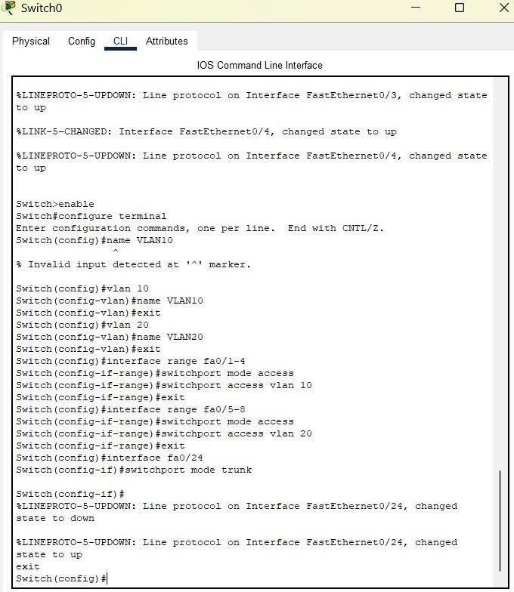

**Switch 1 configuration:**

Switch>enable

Switch #configure terminal

Enter configuration commands, one per line. End with CNTL/Z.

**Create VLAN 10**

Switch(config)#vlan 10

Switch(config-vlan)#name VLAN10

Switch(config-vlan)#exit

**Create VLAN 20**

Switch(config) #vlan 20

Switch(config-vlan) #name VLAN20

Switch(config-vlan)#exit

**Assign Ports to VLAN 10:**

Switch(config) #interface range fa0/1-4

Switch(config-if-range)#switchport mode access

Switch(config-if-range)#switchport access vlan 10

Switch(config-if-range) #exit

**Assign Ports to VLAN 20:**

Switch(config)#interface range fa0/5-8

Switch(config-if-range) #switchport mode access Switch (config-if-range) #switchport access vlan 20

Switch(config-if-range) #exit

**Configuring Trunking on Switch 1**

Switch(config)#interface fa0/24

Switch (config-if)fswitchport mode trunk

Switch(config-if)#exit

Switch(config)#

Switch#

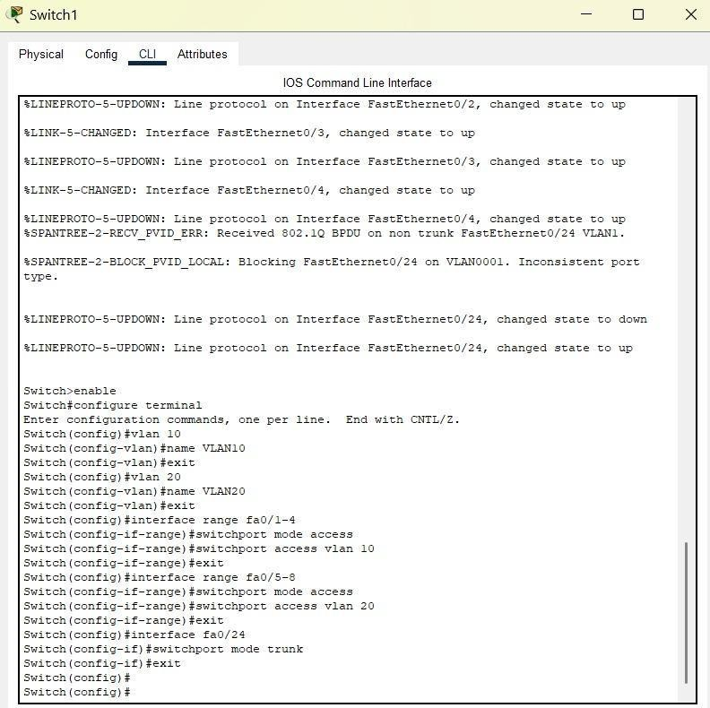

**Verify Connectivity:**

**1. Check Trunk Ports:**

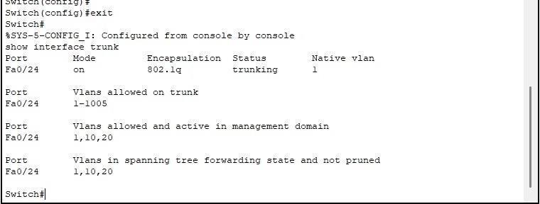

**Check VLANs:**

Switch# show vlan brief

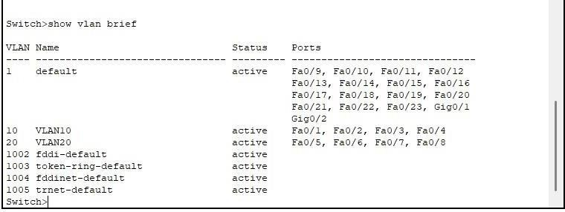

**Step 5: Configure end devices**

1. Assign IP addresses to PCs:

* PC1: 192.168.10.1/24
* PC2: 192.168.10.2/24
* PC3: 192.168.20.1/24
* PC4: 192.168.20.2/24
* PC5: 192.168.10.3/24
* PC6: 192.168.10.4/24
* PC7: 192.168.20.3/24
* PC8: 192.168.20.4/24

**Test Connectivity within VLANs:**

* Ping from PC1 To PC2 (both in VLAN 10)
* Ping from PC3 To PC4 (both in VLAN 20)
* Ping from PC5 To PC1 (both in VLAN 10, across switches)

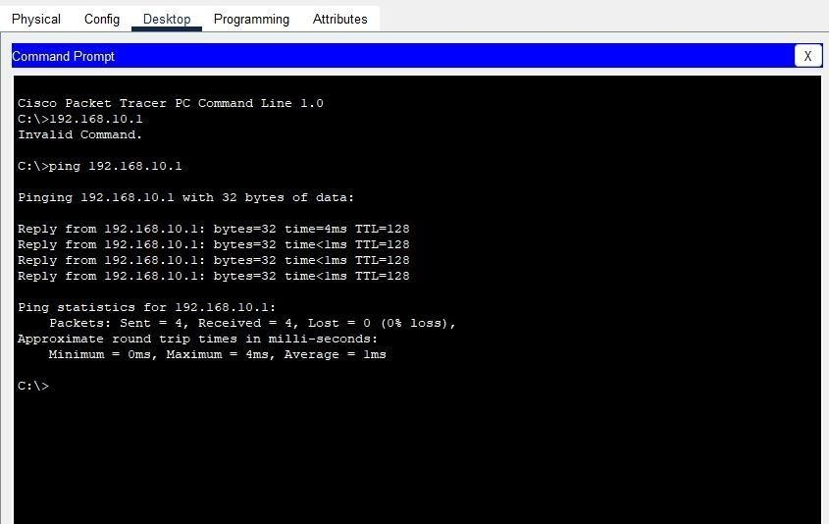

* Ping from PC7 to PC3 (both in VLAN 20, across switches)

**Verify that PCs in different VLANs cannot communicate without a router:**

* Ping from PC1 TO PC3 should fail(VLAN 10 to VLAN 20)
* Ping from PC7 to PC1